9. Подобрать примеры использования SELECT (SQL) c использованием всех возможных атрибутов команды и подчиненных команд SELECT (не менее 10 сложных примеров). Применить в программе команду CREATE DBF, INSERT (SQL). Реализовать данные примеры.

set date to british
create dbf user(surname c(10), firstname c(1), lastname c(1), testid n(10), flagtest l(1), answercounter n(10), time d(8))

insert into user(surname, firstname, lastname, testid, flagtest, answercounter, time) values("Баранов","А","А","5","T","3","04/25/04")

insert into user(surname, firstname, lastname, testid, flagtest, answercounter, time) values("Боровиков","И","А","8","F","8","03/22/04")

insert into user(surname, firstname, lastname, testid, flagtest, answercounter, time) values("Бузданова","Т","В","3","T","5","03/03/04")

insert into user(surname, firstname, lastname, testid, flagtest, answercounter, time) values("Власов","В","В","6","F","3","03/14/04")

insert into user(surname, firstname, lastname, testid, flagtest, answercounter, time) values("Волокитин","М","В","1","T","8","03/15/04")

insert into user(surname, firstname, lastname, testid, flagtest, answercounter, time) values("Гошев","И","А","6","T","1","03/17/04")

insert into user(surname, firstname, lastname, testid, flagtest, answercounter, time) values("Дмитриев","В","В","9","T","9","03/25/04")

insert into user(surname, firstname, lastname, testid, flagtest, answercounter, time) values("Додонов","А","А","4","F","5","02/02/04")

insert into user(surname, firstname, lastname, testid, flagtest, answercounter, time) values("Комаров","П","А","2","F","3","03/01/04")

insert into user(surname, firstname, lastname, testid, flagtest, answercounter, time) values("Кошелев","А","Е","7","T","8","03/19/04")

insert into user(surname, firstname, lastname, testid, flagtest, answercounter, time) values("Матвеев","С","Н","8","T","5","03/13/04")

insert into user(surname, firstname, lastname, testid, flagtest, answercounter, time) values("Морозов","С","В","5","F","2","03/18/04")

close databases
select * from usertab

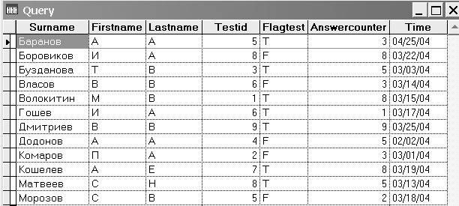

1) Вывод отличников
select * from user where answercounter>=8
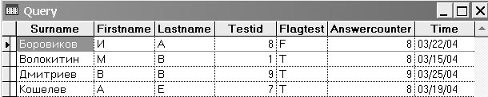

2) Вывод двоечников
select * from user where answercounter<3

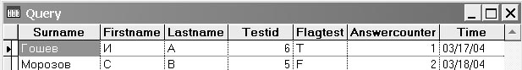
3) Вывод студентов, которые тестировались по тесту № 5
select * from user where testid=5

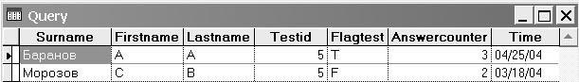

4) Вывод хорошистов, с отчеством «А»
select * from user where answercounter>5 and lastname="À"

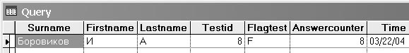

5) Вывести соотношения Студент -> кафедра
select user.surname,info.kafedra from user,info where info.testid=user.testid

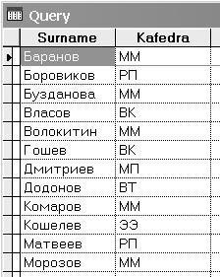

6) Вывод всех, кто тестировался и, если тестировался, то кто автор теста
select user.surname,info.teacher from user,info where user.flagtest and info.testid=user.testid

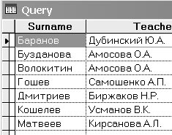

7) Вывести неповторяющиеся Имена
select distinc * from user where firstname="И"

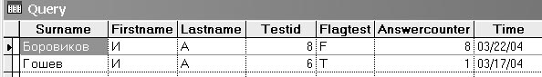

8) Вывести фамилии студентов, которые прошли тесты Кирсановой
select user.surname from user where user.testid=(select testid from info where teacher="Кирсанова А.Л.")

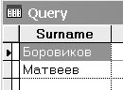

9) Вывести авторов самых сложных тестов
select info.teacher from info where info.testid=(select user.testid from user where user.answercounter=2)

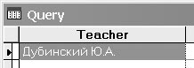

10) Общее количество тестов
select COUNT(info.testid) from info

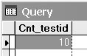

11) Вывести в алфавитном порядке авторов теста и их ученые звания
select distinc teacher as "Автор", zvanie as "Звание" from info order by teacher

